

 | 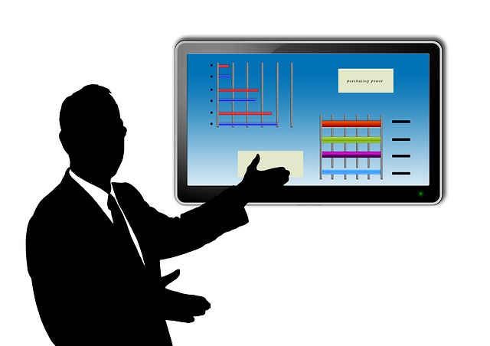
Speaking with
PowerPoint
Designing & delivering effective PowerPoint presentations

May 2016 |  | 

